MODEL EXAMINATION
OUTPUT
Name:Preete.V
Reg No:192572004
Course name:Cloud Computing
Courese code:CSA1511

1. Create a simple cloud software application for Flight Reservation System using any
Cloud Service Provider to demonstrate SaaS include the necessary fields such as one
way, round trip, From, to, Departure, Departure, Travelers & Class, Fare Type,
International and Domestic Flights etc.
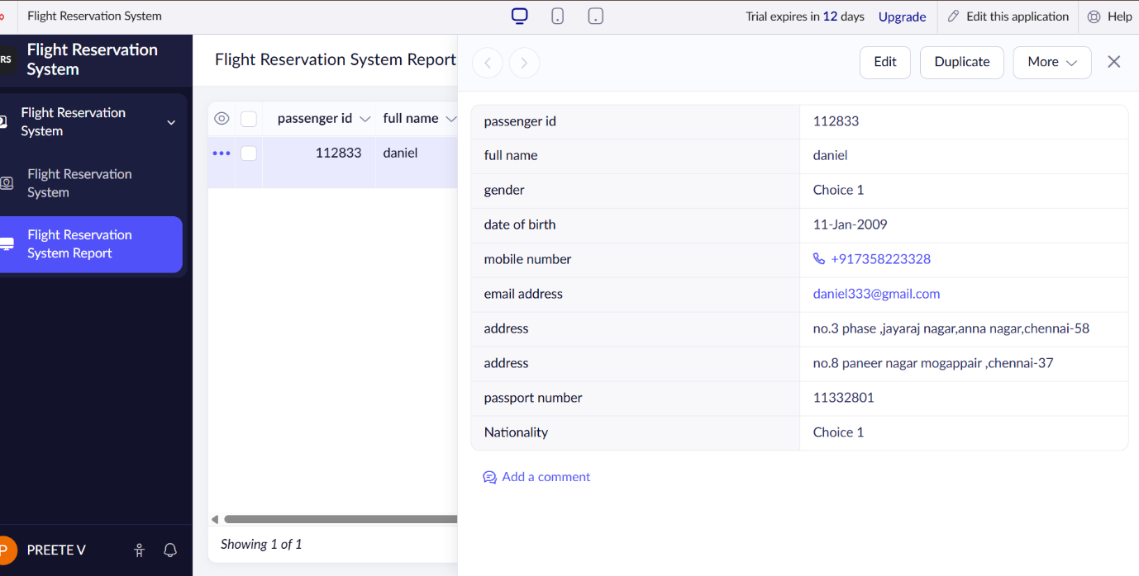
2. Create a simple cloud software application for Property Buying & Rental process (InChennai city) using any Cloud Service Provider to demonstrate SaaS include the necessary fields such as Buy, Rent, commercial, Rental Agreement , Rental Agreement, Area, place, Range, property value etc.
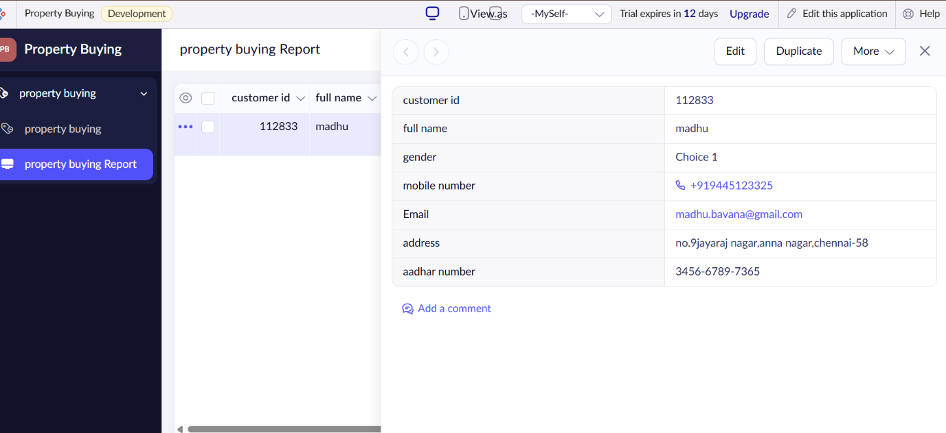

8. Create a simple cloud web application for student counselling system using any Cloud Service Provider to demonstrate SaaS with the fields of student name, age, address, phone, subjects studied, Year of passing, percentage of marks, domain interest, etc.
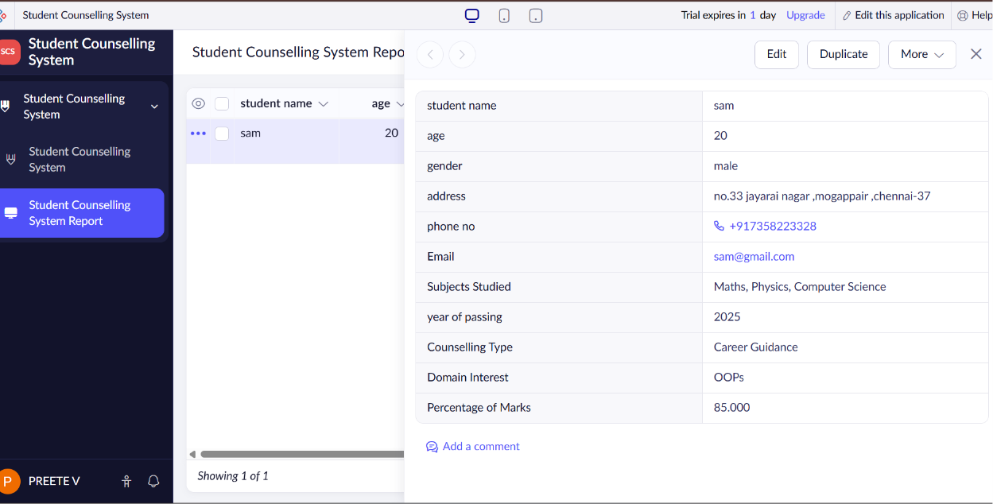
11.Create a simple cloud software application for online super market using any Cloud Service Provider to demonstrate SaaS with the template of customer name, address, phone, email, items, quantity etc. with the itemclassification form.
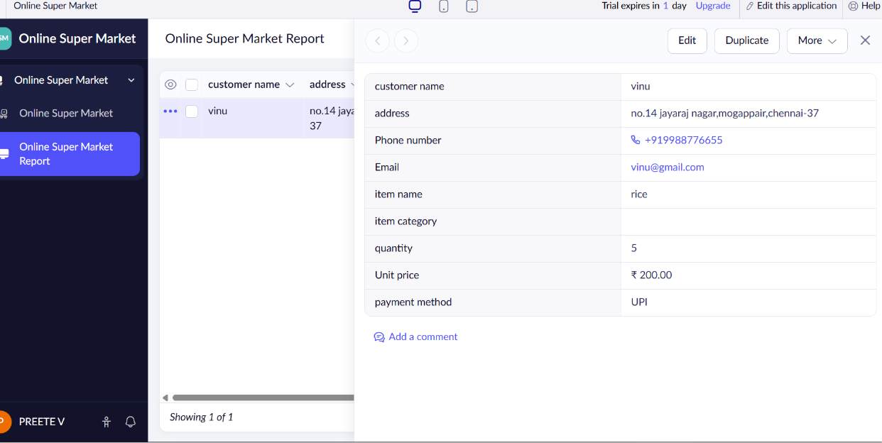

21. Install Virtualbox/VMware Workstation with different flavours of linux or windows OS on top of windows 7 or 8.
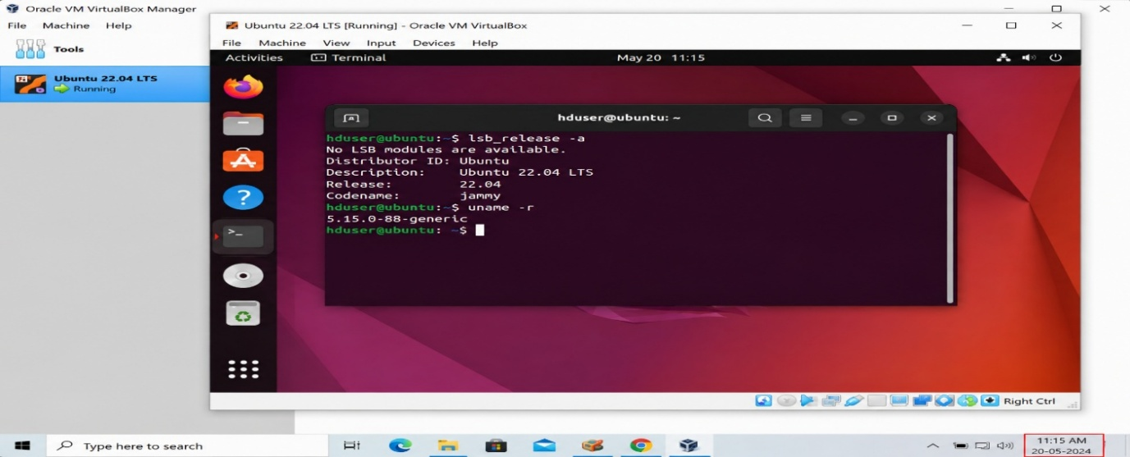
35. Demonstrate Platform as a Service (PaaS) create and configure a new VM Image in any Public Cloud Service Provider to get windows server Gen2.
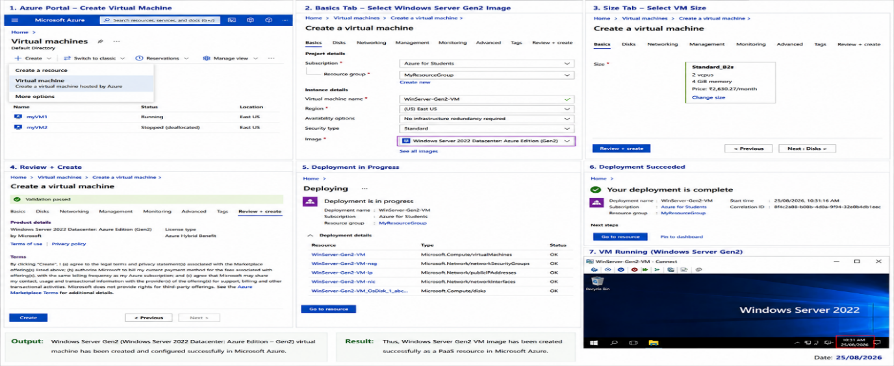
40. Launch the Hadoop 2.x and test the Map-Reduce Platform with Hadoop.

